Description of the Proposed Scheme

This is an extract from Luas Finglas EIAR Chapter 5 Description of the Proposed Scheme.
The proposed Scheme runs from Broombridge to Charlestown through Tolka Valley and Finglas Village and is shown in Volume 4 – Map Figure 1-1. The proposed Scheme is described from south to north, has been sub-divided into four distinct areas as per the following geographical sections:
- Area 30 Broombridge Depot;
- Area 31 Broombridge to Tolka Valley Road;
- Area 32 Tolka Valley Road to Finglas Village Stop; and
- Area 33 North of Finglas Village Stop to the Terminus (Charlestown Stop).

Area 30: Broombridge Depot
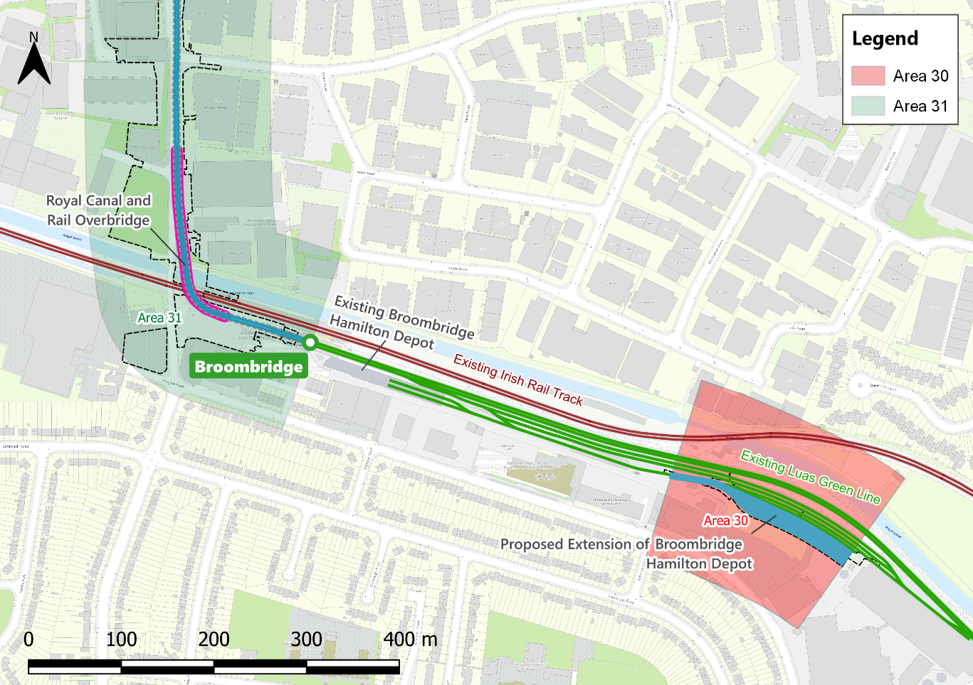
Figure 5-1: Area 30 Broombridge Depot

General overview
Area 30 is shown in Figure 5-1. The extension of the Luas with the addition of 3.9km of track to Charlestown Terminus will ultimately require additional vehicles to provide for the increased demand generated by the combined new and existing alignments and the increased frequency of LRVs. The current stabling facilities at Broombridge Hamilton Depot are at capacity and therefore it is necessary to provide new stabling lanes for these additional vehicles. Following a full assessment of alternative locations for this additional stabling (see Chapter 4 (Alternatives Considered) of this EIAR) a site at Bannow Road was selected as the most viable option. Following design optimisation, the footprint of the stabling area was reduced by one lane to four lanes. This has a positive impact of reducing land take from DCC and thereby reducing impacts on the potential development of the adjacent DCC property. The site was formerly a light industrial premises which was demolished some time ago. The area has not been maintained and is significantly overgrown. The site is shown in Figure 5-2 and the proposed stabling site layout is shown in Figure 5-3.
The extended stabling area consists of three ballasted tracks and a fourth as an embedded track lane to facilitate vehicular access. The stabling area will have provision for eight LRVs. The site requires re-levelling, a retaining wall and a new boundary fence to the southern side. Other facilities include amended overhead line installation, modification of the existing points to link to the existing trackwork, lighting, signalling, water supply (for cleaning) and an extended CCTV system. There will also be modifications to the existing substation although these are internal changes only and do not give rise to any visual impact externally.
A future DCC housing scheme is proposed to the south of the stabling area and suitable planting with a noise and visual buffer
strip is provided as part of that scheme. Construction of the stabling area is proposed to be facilitated via the existing depot access road and will not require access via this proposed housing development site.
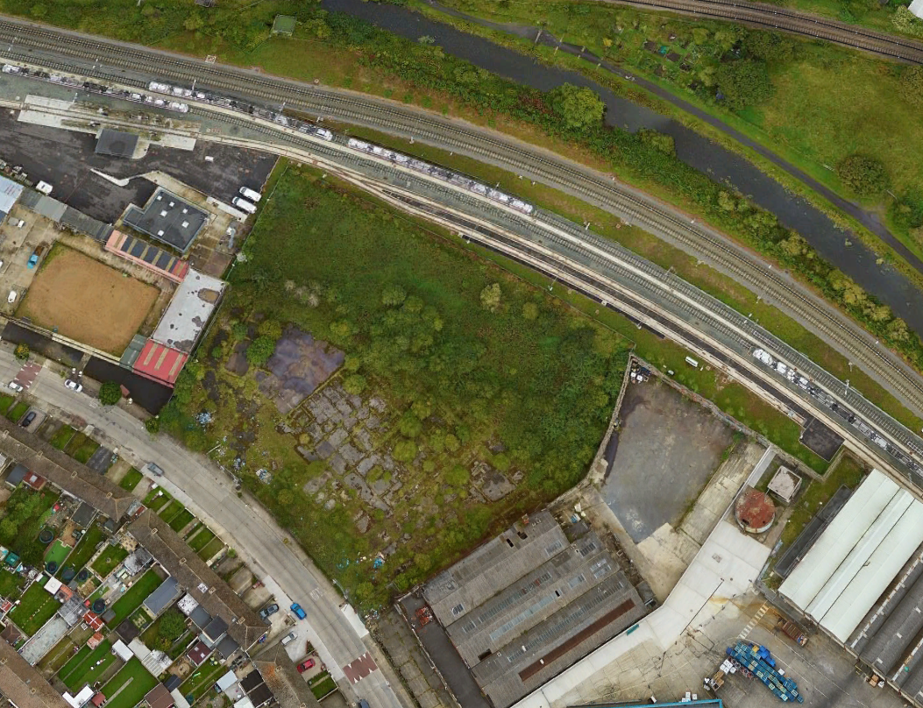
Figure 5-2: Aerial view of existing site for Luas Finglas stabling area

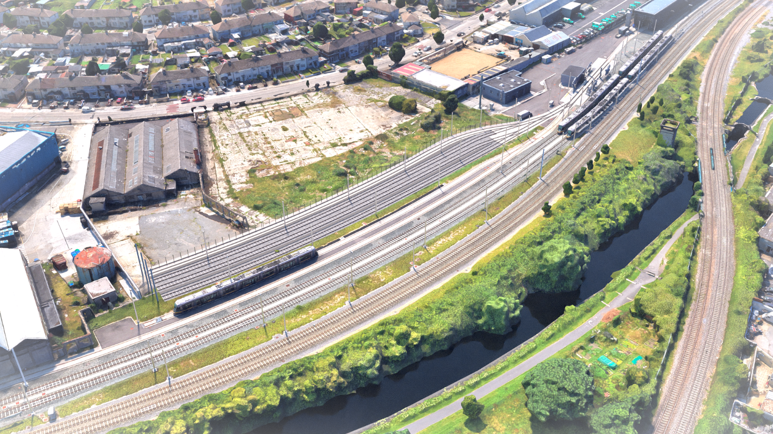
Figure 5-3: 3D Rendered Image at proposed Broombridge Depot Stabling Site

Luas Stops
Area 30 contains the existing Luas Broombridge Stop, which the location and type is indicated in Table 5-2. The proposed Scheme does not require any modifications to this Stop. The existing terminal poles for the Overhead Contact System (OCS) system will be modified to enable the connection to the new OCS for the extension. No new Luas Stops are proposed in Area 30 as part of the proposed Scheme.

Table 5-2: Luas Stops within Area 30 of the proposed Scheme
Luas Stop Name : Broombridge Stop. Location : Existing Broombridge rail / Luas station off Broombridge Road. Description : Existing Luas Stop to remain as it is now.

Junction Information
There are no existing or proposed road junctions in Area 30 as part of the proposed Scheme.

Landscape and Public Realm
The stabling site is within an area inaccessible to the public and is a constrained site with four stabling tracks. Thus, limited opportunities exist for landscape treatment apart from boundary treatment with the adjacent DCC site. This is proposed to take the form of a retaining wall with chain link fence above which can be used for climber planting, to act as an effective visual and sound barrier for the proposed adjacent future housing development.
Within the stabling site there are both ballasted and embedded track for vehicular access and the existing type of track-bed treatment is proposed for the extension. A recently constructed concrete boundary wall exists to the east of the alignment. The current boundary fence to the existing stabling will be removed.
It is noted that the proposed Scheme requires the removal of existing trees at the eastern end of the stabling area. Refer to Chapter 21 (Landscape and Visual Impact) and Volume 5 – A21.2 of this EIAR, for further detail on the number of trees to be removed and impact assessment.

Utilities and Diversions
There are no records of existing utilities within the Area 30 stabling site. Any unchartered existing underground utilities will
be required to be diverted where conflicting with the proposed Scheme. Identified service conflicts and recommended diversions are described and assessed in Chapter 17 (Material Assets: Infrastructure and Utilities) of this EIAR.

Land Acquisition and Use
Temporary land acquisition will be required within Area 30 along the southern side the new boundary line of the stabling site. Depending on the timing of the proposed DCC housing development on the adjacent site, this boundary wall could potentially be in place prior to construction of the stabling site works commencing. Should this be the case, temporary land take will not be required.
Permanent land acquisition is required within Area 30 to facilitate the additional stabling lanes.
Land requirements are detailed in Chapter 12 (Land Take) of this EIAR and are illustrated on the Property Drawings provided in the RO Drawing Pack. The impacts on residential amenity arising from land acquisition in Area 30 of the proposed Scheme are addressed in Chapter 8 (Population). Similarly, the impacts on landscape amenity arising from land acquisition in Area 30 of the proposed Scheme are addressed in Chapter 21 (Landscape & Visual Amenity).

Area 31: Broombridge to Tolka Valley Road
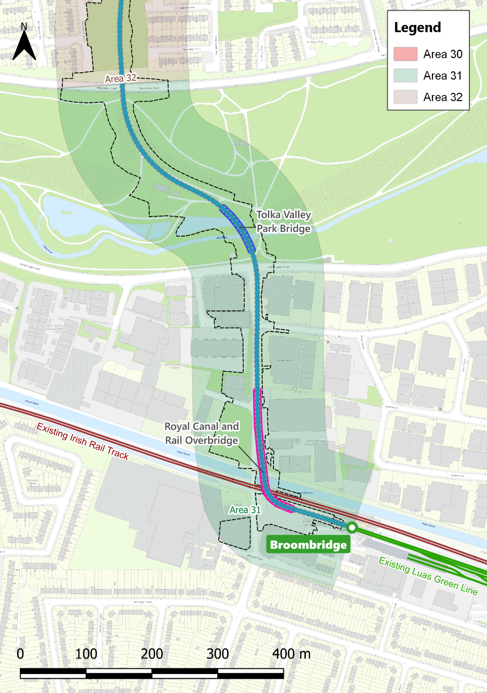
Figure 5-4: Area 31 Broombridge to Tolka Valley Road

General Overview
This area is approximately 850m long, extending from the existing Luas Green Line at Broombridge to Tolka Valley Road. This section will include two major structures: the crossing of the existing Maynooth Railway line, Royal Canal and Greenway; and
the crossing of Tolka Valley Park and River Tolka. No new Luas Stops are included in this section. The area is shown in Figure 5-4.
The proposed Scheme in this location will entail removal of the existing OCS end poles at Broombridge Stop and connection to the new OCS. Trackwork connections will require the removal of the current LRT arrestor and provide for connection of the new track. The work also includes reconfiguration of the interchange area which is described further in the Landscape section 5.7.2.6.
The new track will commence to rise on a new solid ramp structure just west of the Broombridge Stop platform. This ramp connects to the proposed bridge above the Maynooth railway line and the Royal Canal. The height of the bridge deck has been determined by the clearance requirements for both the canal and railway line, taking into account the future electrification of the Maynooth railway line. The area under the bridge will be used to accommodate a cycle storage facility which will further accommodate and encourage cycle-LRT trips.
The proposed Royal Canal and rail bridge has been designed with input from both Waterways Ireland and Iarnród Éireann, as well as consultations with DCC and it takes account of the existing heritage structure and visual impacts while at the same time seeking to provide a landmark and visually attractive structure. The bridge spans clear across both the railway line and the canal with a set of piers on the south side adjacent to the Iarnród Éireann platforms (effectively forming an arched opening to allow access to the Iarnród Éireann platforms) and a set of piers on the northern side just beyond the existing wing walls of Broome Bridge. Access beneath the bridge deck on this side is provided for Waterways Ireland maintenance vehicles and for both pedestrians and cyclists using the canal towpath

and greenway. The proposed bridge is for the exclusive use of the LRT and does not accommodate pedestrians or cyclists.
The current steel pedestrian access ramp to the Iarnród Éireann northern platform at Broombridge has to be removed, due to lack of clearance beneath the proposed bridge, and the stone bridge parapet reconstructed at the existing gap. Alternative access to the Iarnród Éireann platform is available via the Luas platforms from Broombridge Road and the existing overbridge between the Iarnród Éireann platforms. Iarnród Éireann have submitted an RO application for the DART+ West project which includes the modification of the existing Broome Bridge structure to accommodate the increase in clearance due to the electrification of the line. This has been taken into account in the design of the proposed Scheme.
These works include a proposed diversion of a water main at Broombridge Road/Bridge which requires construction of a pipe duct beneath the Royal Canal and main line Railway. This work will be carried out by means of pipe-jacking underneath both these locations to minimise disruption.
The proposed Royal Canal and rail bridge structure continues along the eastern boundary of the Colorman factory. A new vehicular access is to be provided to the Colorman business premises beneath the bridge. The structure terminates in a solid ramp structure just south of Lagan Road where the track reaches existing ground level to proceed northwards via a new signalled junction. The alignment continues past the business Fashionflo, where the boundary walls are to be relocated. At the Westrock premises, demolition of an existing retaining wall and reconstruction of a new wall in a position closer to the building is proposed. Some modification works are required to accommodate access for goods vehicles and staff to Fashionflo, including provision of new access gates on Lagan Road. The
Page 10
track construction in this area consists of slab track construction for structures, embedded track for road crossings and grass track elsewhere.
Road works at Broombridge Road include road re-alignment both horizontally and vertically to accommodate the track alignment and access to adjacent properties. Additional widening is required to provide the necessary cycle lanes, footpaths and landscape buffer zones. The proposed Scheme includes changes to the access arrangements and boundary walls along both sides of Broombridge Road. The existing mini-roundabout at the entrance of the Glen Industrial Estate will be changed to a priority junction and measures will be put in place at Lagan Road junction to indicate to drivers that access is restricted across the bridge in a southbound direction, utilising surfacing treatment, signage and landscaping measures. Differences in level require the construction of a new retaining wall along the front of the Glen Industrial Estate south of the current entrance location. A building located in Glen Industrial Estate to the north of the existing entrance must be demolished as a result of the widening of the roadway. Further north, works include new boundaries and the demolition of Unit 124, Broombridge Close.
Other works at Broombridge Road include utilities diversion works and provision of new public lighting as well as below ground construction for track bed, ducts, pole and structure foundations.
The proposed Scheme crosses Ballyboggan Road at grade via a new signalled junction and then enters Tolka Valley Park. The existing access gates will be removed and a more open access point will be provided. (See details in section 5.8.11).
The proposed Scheme crosses the River Tolka via a new bridge which will feature a grass/green deck. A parallel cycle lane is
also provided. The overall length of the bridge is 65m, consisting of a central span of 45m and two 10m edge spans. The two 10m end spans have side walls which block the space beneath them. The south pier is approximately 5m from the riverbank whereas the north pier is set back approximately 22m from the riverbank to minimize the impact on the existing Integrated Constructed Wetland (ICW).
The proposed Scheme continues north, rising towards Tolka Valley Road. Here the proposed Scheme passes through an area of contaminated land associated with the old municipal dump. The proposed Scheme also passes in two locations beneath a set of ESBN high tension wires. This has been assessed for clearance and safety/EMC impacts and is not of concern. The existing footpaths and cycle lanes within the park are modified to ensure safe crossing points for both pedestrians and cyclists alike.
The proposed Scheme crosses Tolka Valley Road at grade via a new signal-controlled crossing. Existing railings around the park will be modified to facilitate the LRT crossing and new landscape layouts will be provided (See details in section 5.8.11)

Other Minor Works
Some works are required within the curtilage of adjacent owner/occupiers’ premises to facilitate new circulation and access movements due to loss of space or points of access. There will also be minor works for the provision of electrical and control cabinets for the various systems such as public lighting and signalling. Works within the park include new footpaths, cycle lanes and public lighting.

Luas Stops
No Luas Stops are proposed in Area 31 as part of the proposed Scheme.

Junction Information
An overview of the approach to junction review and design is provided in section 5.8.4.15. The proposed scheme junctions within Area 31 are outlined in Table 5-3.
Table 5-3: Junctions within Area 31 of the proposed Scheme
Junction : Broombridge Road – Colorman Business. Junction Detail. New access to be provided underneath the elevated track structure. Footpath on Broombridge Road for continuous access across. A 7m width on access for the swept path. Gate to be located within Colorman site.

Junction : Broombridge Road – Glen Industrial Estate. Junction Detail . Replacement of existing mini-roundabout with T-junction. A 6m road width, and 6m junction corner radii to facilitate informal U-turns. A ramped crossing for paths with drivers required to give priority to path users.

Junction : Broombridge Road / Lagan Road. Junction Detail . Replacement of existing priority junction with a signalised junction incorporating a Luas crossing of Lagan Road. 6m junction corner radii.

Junction : Broombridge Road / Ballyboggan Road. Junction Detail . Replacement of the existing priority junction with a signalised junction incorporating a Luas crossing of Ballyboggan Road. 6m junction corner radii. A segregated 2-way north-south running cycle track retained through junction and provided with dedicated traffic signal phase.

Structures

Major Structures
Two principal structures currently exist in Area 31. The location and type of structures is indicated in Table 5-4.
Table 5-4: Summary of Existing Principal Structures in Area 31 of the proposed Scheme
Identity : Broome Bridge (RPS ref. 909). Description : It currently carries Broombridge Road over both the Royal Canal and, with a later incorporated archway, the Maynooth Rail Line (former Midland Great Western Railway Line). The Broombridge Iarnród Éireann station and Broombridge Luas Terminus are located adjacent to the eastern elevation of the bridge.
Identity : Finglaswood Bridge (RPS Ref: 906). Description : An existing two-arch structure that crosses the River Tolka and provides mostly pedestrian and park maintenance vehicle access across the river within the Tolka Valley Park amenity area.
Two new structures are proposed in this Area as part of the proposed Scheme.
- Royal Canal and Rail Bridge; and
- Tolka Valley Park Bridge.
The location and type of these structures is indicated in Table 5-5 and described in further detail in Section 5.8.10.
Table 5-5: Summary of New Structures in Area 31 of the proposed Scheme
Identity : Royal Canal and Rail Bridge. Location :Approximately 10m east of the existing Broome Bridge and then continuing north, parallel with Broombridge Road on its east side. Description : The proposed bridge is an eight-span structure
consisting of two main parts: a variable depth weathering steel composite box girder followed by a constant depth solid concrete slab. The bridge has the following span arrangement: 35 + 47.5 + 30 + 17 + 3x22 + 17m. Steel superstructure extends over the first three spans. The bridge deck is continuous over the full length of 212.5m and has solid approach ramps at both ends.
Identity : Tolka Valley Park Bridge. Location : Approximately 30m west of the existing Finglaswood Bridge. Description : A three-span structure with buried end spans, thus appearing as a single span bridge. End spans as well as part of the main span consist of post-tensioned concrete variable depth girder, the central section of the main span is a suspended weathering steel composite box girder. The overall length of the bridge is 65m with spans 10m, 45m, 10m. Abutments and piers are set at 0 degrees skew and the superstructure is fully integral with the substructure.

Retaining Walls
There are several retaining walls proposed within this section of the proposed Scheme at the locations below:
- Just north of the existing Broome Bridge on the western side of Broombridge Road, along the frontage of Glen Industrial Estate;
- On the western side of Broombridge Road opposite the junction with Lagan Road;
- The Eastern side of Broombridge road between Lagan Road junction and start of the Royal Canal and Rail Bridge approach ramp; and
- South of the Ballyboggan Road / Broombridge Road Junction on the eastern side of Broombridge Road, in front of the Westrock premises.

Page 15

Landscape and Public Realm
The proposed new layout for the Broombridge Stop provides for improved access for bus, pedestrian and mobility-impaired passengers and it frees up space for additional soft landscaping together with a reduction in the area of hard surfaces. On Broombridge Road, there are extensive landscape changes proposed. The design intent is to transform what is currently a somewhat unfriendly pedestrian and cycle area into a more appropriate environment to facilitate and encourage walking and cycling, and to tie into the proposed Royal Canal Greenway along the Canal tow path as well as providing enhanced access to and from the Luas Stop and the Iarnród Éireann platforms.
The landscape works through Tolka Valley address issues at the entrances of the park which move away from having boundary fencing / gates to a more open aspect due to the LRT crossing. In line with DCC policy only minimal lighting is provided within the parks where safety dictates it is necessary.

Utilities & Diversions
Existing underground utilities will be diverted due to the proposed development. The following utilities have been identified as requiring works in Area 31:
- Uisce Éireann (Irish Water): asset owners for potable water, foul drainage and combined drainage;
- Local Authorities – DCC:
- Asset owners of: Public Lighting, Traffic, Local CCTV Fibre, and surface drainage.
- ESBN: High voltage and Medium / Low voltage overhead and undergrounded network;
- Gas Networks Ireland: High pressure and low-pressure mains; and
- Various communications networks.
Information regarding location-specific utility clashes and the required diversions are covered in detail in Chapter 17 (Material Assets: Infrastructure and Utilities) of this EIAR.

Land Acquisition and Use
Temporary land acquisition is required within this Section at several locations, including the construction compound and laydown / storage space in the DIT site opposite the Luas Interchange, temporary land within the Glen Industrial Estate lands for bridge construction and space within the Tolka Valley Park to facilitate bridge and track construction. Other temporary lands are required for boundary wall and retaining wall construction.
Permanent land acquisition is required within this Area 31 facilitate track and road alignment, pedestrian / cyclist facilities and structures.
Land requirements are detailed in Chapter 12 (Land Take) of this EIAR and are illustrated on the Property Drawings provided in the RO Drawing Pack.
The impacts on residential amenity arising from land acquisition in Area 31 of the proposed Scheme are addressed in Chapter 8 (Population). Similarly, the impacts on properties arising from land acquisition in Area 31 of the proposed Scheme are addressed in Chapter 12 (Land Take). Finally, the impacts on landscape amenity arising from land acquisition in Area 31 of the proposed Scheme are addressed in Chapter 21 (Landscape and Visual Amenity).

Area 32: Tolka Valley Road to Finglas Village Stop
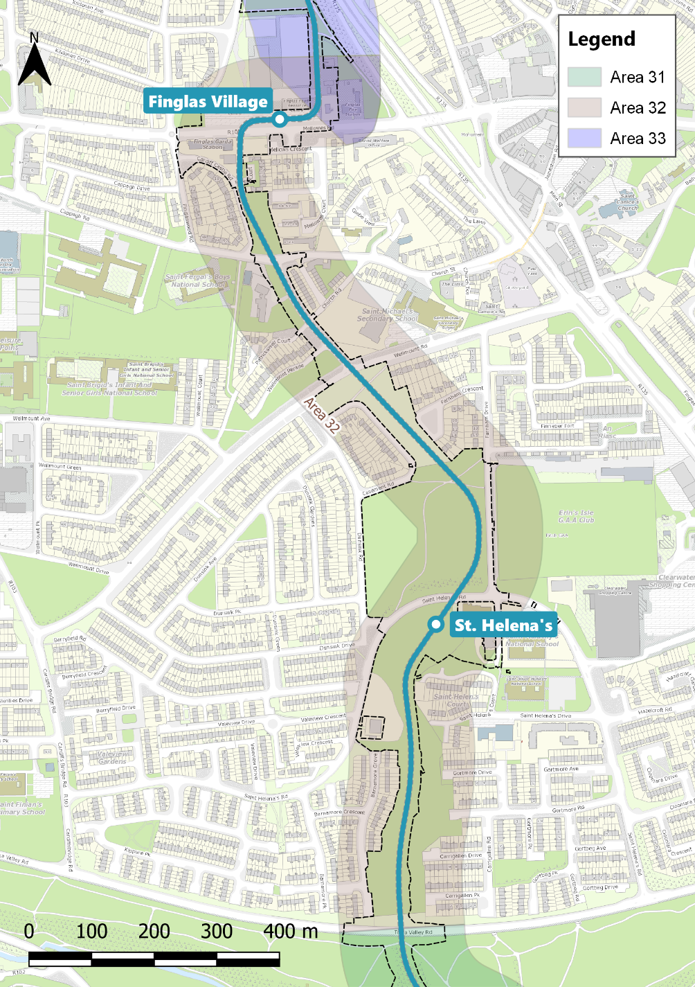
Figure 5-5: Area 32 Tolka Valley Road to Finglas Village Stop

General Overview
This area is approximately 1.45km long running from Tolka Valley Road to Finglas Village Stop and includes two Stops: St Helena’s and Finglas Village. The area is shown in Figure 5-5.
The alignment rises through the grassed area between Tolka Valley Road and St Helena’s Road, a former valley, (locally
known as “The Valley”), which contained the Finglaswood Stream that has since been culverted and infilled. This culvert is proposed to be diverted as part of the proposed Scheme. Parallel to the alignment there are new footpaths and a cycle lane. The area currently has no formal footpaths although an existing strong “desire line” worn path is clearly evident. The introduction of the proposed Scheme is likely to increase the use of that desire line and in order to avoid informal usage of the track footprint, a parallel layout of cycle lanes and footpaths is proposed. The design of the footpaths has taken into account accessibility and issues such as antisocial behaviour and public safety.
The first Stop on the proposed Scheme is located just south of St Helena’s Road adjacent to the St Helena’s Family Resource Centre and the St Helena’s Childcare Centre. The location of the Stop has taken into consideration pedestrian access and bus interchange with services on St Helena’s Road. In order to facilitate safer crossings at the Luas line and St Helena’s Road junction, the access arrangements for the Resource Centre and Childcare Centre have been modified so that all vehicular access will be via Farnham Drive extension. The internal layout of the Resource Centre and Childcare Centre car park is being reconfigured to suit. A small turning hammerhead is proposed at the end of Farnham Drive extension to facilitate the parents of children attending St Malachy’s primary school. Farnham Drive extension will be re-engineered to re-balance its function more towards the needs of vulnerable road users and to reflect its location beside a school access.
A new signal-controlled junction is created on St Helena’s Road and from here, the proposed Scheme crosses into the area of Farnham pitches and runs parallel to Farnham Drive. There are two pitches at this location for both Gaelic games (GAA) and soccer. In order to accommodate the proposed Scheme, the
pitches are to be modified and relocated. Due to space limitations, the alignment will have ball-stop net protection at the corners of the GAA pitch. The alignment is slightly elevated above the pitch level and the resulting embankment will provide a viewing area for spectators. Within the pitch areas, the existing footpath dividing the current playing fields will be removed and the entire area will be re-levelled. Safe crossing points for pedestrians have been provided at the alignment and Farnham Drive to facilitate access for the Erin’s Isle GAA club. A small equipment storage structure is proposed at this location.
North of the Farnham pitches, the track continues through the parklands alongside Casement Road before arriving at a controlled crossing of Wellmount Road. The alignment continues northwards through Patrickswell Place where the existing road is realigned westwards to accommodate the proposed Scheme within the existing corridor. This area may contain archaeological remains of King William’s Ramparts. The impacts on this have been assessed in Chapter 20 (Cultural Heritage). The alignment then continues to cross Cappagh Road via a new signal-controlled junction. Continuing at grade parallel to Cardiff Castle Road, the alignment then crosses the entrance to Ravens Court, a residential complex of 12 units. Works here include relocation of the existing boundary wall and changes to the entrance to the complex in order to ensure intervisibility and safe crossing of the proposed Scheme.
At this point, the alignment runs through the Finglas Garda station where it effectively bisects the current parking area and necessitates the demolition of an existing building structure at the rear of the station as part of the proposed Scheme. The relocation of the facility is being planned by An Garda Síochána and the Office of Public Works (OPW) and close coordination with the OPW is required in regard to timing of construction. At this point, the proposed Scheme will create a new cut-through
street linking Cardiff Castle Road to Mellowes Road, with a footpath provided adjacent to and crossing the alignment.
Having crossed Mellowes Road via a new signal-controlled junction, the proposed Scheme turns sharply eastwards to arrive at the Finglas Village Stop. The Stop is positioned parallel to Mellowes Road and is incorporated into a new civic plaza which will enhance access to the nearby community facilities. The location of the Stop also facilitates better connectivity with the bus services running along Mellowes Road and provides a more direct visual link to Finglas village centre. A secure cycle parking facility is provided at this location.

Other Minor Works
Within Area 32, cycle storage facilities at Finglas Village Stop and additional equipment storage facilities needed for the pitches at Farnham are being provided. Provision of minor retaining walls and boundary fences at the Garda station and near Cardiff Castle Road are also required.

Luas Stops
Two Luas Stops are included in Area 32 as part of the proposed Scheme. The Luas Stop locations are outlined in Table 5-6 and are illustrated on the Architectural and Landscaping Drawings provided in the RO Drawing Pack.
Table 5-6: Luas Stops within Area 32 of the proposed Scheme
Luas Stop Name : St Helena’s Stop. Location : South of St Helena’s Road beside the St Helena’s Family Resource Centre and the St Helena’s Childcare Centre
Luas Stop Name : Finglas Village Stop. Location : North of Mellowes Road and in front of the Finglas Youth Resource Centre.

Junction Information
An overview of the approach to junction review and design is provided in Section 5.8.4.15. The proposed Scheme junctions within Area 32, Tolka Valley Road to Finglas Village Stop are outlined in Table 5-7.
Table 5-7: Junctions within Area 32 of the proposed Scheme
Junction: Tolka Valley Road. Junction Detail : Signalised intersection for the alignment crossing of Tolka Valley Road.
Separate pedestrian and cyclist crossings incorporated into the traffic signals. Whole junction area to be on a raised table for traffic calming and to create a change in road character passing through the park setting.
Junction : St Helena’s Road. Junction Detail : Signalised intersection for the alignment crossing of St Helena’s Road.
Pedestrian and cyclist crossings incorporated into the traffic signals. Access to St Helena’s Family Resource Centre and the St Helena’s Childcare Centre at the junction location, to be closed off for vehicle access and an upgraded 2-way access provided instead off Farnham Drive extension.
Junction : Wellmount Road. Junction Detail : Signalised intersection for the alignment crossing of Wellmount Road. Pedestrian crossing incorporated into the traffic signals.
Junction : Cappagh Road / Patrickswell Place. Junction Detail : Signalised intersection for the alignment crossing of Cappagh Road. Patrickswell Place and pedestrian and crossings incorporated into the traffic signals to form a 3-arm junction.
Junction : Ravens Court. Junction Detail : Uncontrolled intersection for the alignment crossing of Ravens Court.
Junction : Mellowes Road. Junction Detail : Signalised intersection for the alignment crossing of Mellowes Road.
Pedestrian crossings incorporated into the traffic signals.

Structures

Retaining Walls
There are several minor low level retaining walls proposed within Area 32 at the following locations:
- West of Farnham Drive near the crossing with St Helena’s Road between the proposed Luas track and adjacent sports grounds (Farnham pitches);
- West side of Patrickswell Place near junction with Cappagh Road;
- North side of Cardiff Castle Road at the boundary with Garda Station grounds; and
- Eastern boundary of the Garda Station where the new road/track alignments cuts through.
All these retaining walls are of masonry construction and where necessary, function also as boundary walls.

Landscape and Public Realm
Within Area 32, the landscape and public realm treatment follows a similar pattern to that established in the southern section of the proposed Scheme, namely grass track through park areas, some minor footpath alterations and boundary treatments such as walls and fences. The amount of embedded track is minimised to junctions, road crossings and Stops.
The area south of St Helena’s Stop is currently unmaintained grass lands and lacks designated footpaths and cycle lanes. The proposed treatment is this area includes new accessible footpaths and a separate parallel cycle lane. Residual areas are landscaped in sympathetic local finishes and materials and
planted with appropriate native and climate resilient species. A SuDS-based approach has again been applied to drainage with a view to creating a more sustainable low maintenance scheme.
Public realm areas around the two Stops includes hard surfacing to facilitate access and the design has been configured to eliminate the need for handrails and balustrades as much as possible at the Stops. Cycle parking areas have been included and links to nearby bus stops and significant attractors such as schools and resource centres have been taken account of.

Utilities and Diversions
Existing underground utilities will be required to be diverted due to the proposed works. The following utilities have all been identified as requiring works in Area 32:
- Uisce Éireann (Irish Water): asset owners for potable water, foul drainage and combined drainage;
- Local Authorities - DCC:
- Asset owners of: Public Lighting, Traffic, Local CCTV Fibre, and surface drainage.
- ESBN: High voltage and Medium / Low voltage overhead and undergrounded network;
- Gas Networks Ireland: High pressure and low-pressure mains; and
- Various communications networks.
Information regarding location-specific utility clashes and the required diversions are covered in detail in Chapter 17 (Material Assets: Infrastructure and Utilities) of this EIAR.

Land Acquisition and Use
Temporary land acquisition is required within this area at several locations, including construction compounds at St Helena’s and just north of Cappagh Road. It is also proposed to use the site of
the Park Superintendent’s house as a construction compound to facilitate construction of the Stop at Finglas Village and the substation. Other minor temporary acquisition is required along the alignment to facilitate construction of boundary walls and crossings.
Permanent land acquisition is required within this area at various locations including through the parklands, along the front of Ravens Court, across the Garda Station and in front of the Community Centre on Mellowes Road.
Land requirements are detailed in Chapter 12 (Land Take) of this EIAR and are illustrated on the Property Drawings provided in the RO Drawing Pack.
The impacts on residential amenity arising from land acquisition in Area 32 of the proposed Scheme are addressed in Chapter 8 (Population). Similarly, the impacts on properties arising from land acquisition in Area 32 are addressed in Chapter 12 (Land Take). Finally, the impacts on landscape amenity arising from land acquisition in Area 32 of the proposed Scheme are addressed in Chapter 21 (Landscape and Visual Amenity).

Area 33: North of Finglas Village Stop to the Terminus at Charlestown Stop
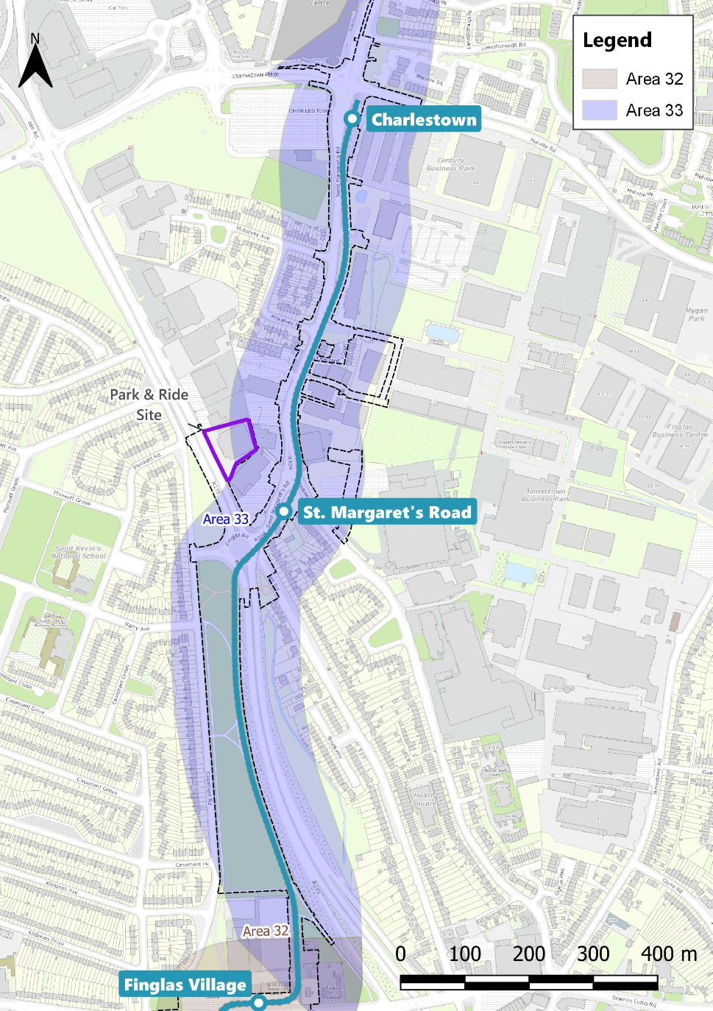
Figure 5-6: Area 33 North of Finglas Village Stop to the Terminus at Charlestown Stop

General Overview
This area is approximately 1.42km long and includes two Stops: St Margaret’s Road and Charlestown Terminus. This area also includes a major road junction with Finglas Road / North Road, and a major upgrade of the whole section along St Margaret’s Road. This area also includes a 350-space P&R facility
accessible off North Road and the two substations which are required for the extension of the Luas network. The area is shown in Figure 5-6.
Exiting Finglas Village Stop, the proposed Scheme alignment turns sharply northwards and continues until it reaches the boundary of Mellowes Park. The alignment curvature necessitates the reconfiguration of an external storage area and the relocation of a boundary fence of the former Park Superintendent’s house, now used as a counselling services office. In this area, the first of the two substations is located. Existing external storage facilities for DCC Parks Department are to be relocated and the current buildings will be demolished. The substation has been positioned within the cleared space sharing a yard space with the adjacent Uisce Éireann (Irish Water) pumping station. The DCC Housing Department has been consulted extensively regarding a future development of the site of the superintendent’s house to provide housing and some mixed-use development. The alignment and access road layout take this into consideration.
The proposed Scheme enters Mellowes Park at the southern end next to the existing Uisce Éireann (Irish Water) pumping station. There is a crossover located just south of this point to facilitate turnback of LRVs for emergency or operational reasons. The proposed Scheme proceeds northward on the eastern side of Mellowes Park using a grass track system. A minor adjustment of the soccer pitch in Mellowes Park is required to accommodate the LRT alignment and adjacent footpath. The proposed Scheme then approaches the existing footbridge near the Liam Mellows memorial garden. This bridge is in conflict with the proposed Scheme and becomes redundant with the introduction of the at-grade Finglas Road / North Road crossing and therefore will be demolished.
The Finglas Road / North Road roundabout is reconfigured to provide a signal-controlled junction with the LRT and pedestrian crossings integrated into the signalling sequence. After crossing the Finglas Road / North Road, the proposed Scheme proceeds northwards along St Margaret’s Road where the next Luas Stop is located. The Stop sits between the Finglas Road / North Road junction and McKee Avenue junction. McKee Avenue junction is currently also a roundabout and will be changed to a signal-controlled junction. The Stop is on a slight curve due to the constrained nature of the site. Space is provided for a public plaza around the Stop and connections to the proposed P&R, located across the road. The proposed Scheme has also taken account of future connections proposed as part of the Jamestown Business Park redevelopment. A bus interchange is provided for proposed BusConnects routes as well as coach stops on Finglas Road / North Road. Provision is made for cycle storage and connections to the GDA cycle network proposed by the NTA.
Just south of the Stop is the proposed second substation. This is to be constructed within a residual area following the demolition of the spiral ramp on the northeastern side of the pedestrian overbridge referred to above. The substation will be accessible via the old North Road which ends in a cul-de-sac adjacent to the site.
An access to the rear of St Margaret’s Stop has been provided to facilitate access to land severed by the proposed Scheme. A secure cycle storage facility is proposed at the rear of this Stop.
Having crossed McKee Avenue, the proposed Scheme continues northwards on the eastern side of St Margaret’s Road. The need to provide space for increased landscaped areas and cycling facilities means there are property and boundary wall impacts on both sides of the roadway. The proposed Scheme
necessitates the demolition and relocation of an electrical substation at the Manhattan Peanuts premises. The scheme proposes to remove access from the front of a number of premises along St Margaret’s Road and a proposed rear access road is included in order to preserve vehicular access to these businesses. These alternative accesses will integrate with the Jamestown Masterplan infrastructure under development by DCC. Consultations with regard to the proposed accesses with DCC and the impacted landowners/leaseholders are ongoing.
The proposed Scheme encroaches on four private gardens at St Margaret’s Court. The existing access road to the court at the rear of these four houses is to be closed and alternative access and parking is provided via the Jamestown Business Park access road which will be signalised. A small area of green space is to be re-purposed for the additional parking and the original access road to St Margaret’s Court will be converted into a cul de sac for parking. This junction has an existing offset arm at McKelvey Road and on the western side a little further north there is an access to and from McKelvey Avenue. It is proposed to close vehicular access at McKelvey Road and convert the end of McKelvey Road to a hammerhead turning area. This will significantly reduce the junction complication and signalling phases. Resident's vehicular access to McKelvey Road is preserved via McKelvey Avenue.
The proposed Scheme continues northwards to cross the access road into the ESBN premises. This access is slightly reconfigured to allow safer crossing of the LRT and to provide some stacking / waiting space for traffic entering and exiting the site.
The proposed Scheme continues northwards until it reaches the terminus station of Charlestown, located just south of Melville Road. A set of crossovers switches will facilitate entry or exit to
either platform at the terminus. The junction at this location is reconfigured with lane reductions and improved access for pedestrians and cyclists in line with DMURS principles. Bus interchange is provided for and there is a proposed cycle parking located next to the Stop.

Other Minor Works
The proposed Scheme in this area will require removal and / or relocation of boundary walls (both residential and business premises) and a number of minor retaining walls will be required. The impact of the land acquisition will necessitate reconfiguration of internal circulation and car parking arrangements for a number of the premises fronting St Margaret’s Road.

Luas Stops
Two Luas Stops are included in Area 33 as part of the proposed Scheme. The Luas Stop locations are outline in Table 5-8 and are illustrated on the Architectural and Landscaping Drawings provided in the RO Drawing Pack.
Table 5-8: Proposed Luas Stops
Luas Stop Name : St Margaret’s Stop. Location: East side of St. Margaret’s Road and south of McKee Avenue junction
Luas Stop Name : Charlestown Terminus. Location : East side of St. Margaret’s Road and south of Charlestown junction

Junction Information
An overview of the approach to junction review and design is provided in Section 5.8.4.15. The proposed Scheme junctions within Area 33 – North of Finglas Village Stop to terminus at Charlestown Stop are outlined in Table 5-9.

Table 5-9: Junctions within Area 33 of the proposed Scheme
Junction : St Margaret’s Road / Finglas Road / North Road / Casement Road. Junction Detail : The existing roundabout is to be replaced with a signalised junction. The junction is designed to be as compact as possible in accordance with DMURS. Protected and segregated cycle tracks are proposed for the east-west movement through the junction. Pedestrian crossings are proposed on all 4 arms with staggered crossings used on the north and south arms.
Junction : North Road / Park & Ride. Junction Detail : A 3-arm signalised junction is proposed on North Road to provide access for the proposed P&R facility to the east of North Road. Right-turns into the facility from North Road will not be permitted. Signalised pedestrian crossings will be provided on two of the arms of the junction.
Junction : St Margaret’s Road / McKee Avenue. Junction Detail : The existing roundabout is to be replaced with a signalised junction with protected cycle tracks. Southbound bus stop located on north side of junction to avoid having congested pedestrian / cyclist activity and interactions beside the Luas Stop. Upgrade of McKee Ave. extended south-eastwards to incorporate proposed priority junction for access road proposal.
Junction : St Margaret’s Road / McKelvey Road /Jamestown Business Park. Junction Detail : The existing uncontrolled operation of these junctions will change to a controlled, traffic signalled junction. The traffic signals will also effectively cater for the needs of vulnerable road users. McKelvey Road vehicular access at the junction will be closed off. Pedestrian and bicycle access would be retained, a turning area would be provided at the end of McKelvey Road, and all vehicular access to and from St Margaret’s Road would be via McKelvey Avenue. Cycle tracks are kept off-road, they are segregated and protected.
Junction : St Margaret’s Road / McKelvey Avenue. Junction Detail : The existing uncontrolled junction will remain as uncontrolled but with a ramped crossing for paths with, drivers required to give priority to pedestrian and cyclists are per normal convention.
Junction : St Margaret’s Road / ESBN. Junction Detail : The existing uncontrolled junction will remain as uncontrolled with a 6m dwell area between St Margaret’s Road and the cycle track / alignment. This will allow for vehicles to navigate crossing the cycle track / alignment line and the uncontrolled junction in two movements.
Junction : St Margaret’s Road / Charlestown. Junction Detail : The proposed signalised junction upgrade at Charlestown will involve provision of a more compact and VRU-friendly junction consistent with current best design practice and DMURS. The other main change to Charlestown junction is the introduction of protected cycle track infrastructure. Pedestrian crossings have been kept as short as feasible. It is proposed to upgrade the east arm (Melville Road) for 100m in order to provide cycle track connectivity to the existing cycle tracks to the east. The existing off-road cycle track left-turn “bypass” lane on the northwest corner shall be retained: Similarly, a new off-road cycle track left-turn “bypass” lane is proposed on the southwest corner.

Structures

Major Structures
A new Park & Ride (P&R) facility is proposed for the scheme. The P&R site is located in the north-eastern corner of the existing North Road, Finglas Road, St Margaret’s Road roundabout. The
Page 32
proposal is to provide a multi-storey car park on the site currently occupied by Discount DIY to the north of the Lidl site. The building is six storeys high including the ground floor. Approximately 350 car parking spaces will be provided. The facility is designed to facilitate 100% EV parking with approximately 20% of EV spaces provided from opening year. There will be pedestrian access to the North Road. Further details are provided in section 5.8.6.
The proposed Scheme also requires the removal of the existing pedestrian bridge and ramps at the Finglas Road / North Road roundabout.

Minor Structures
The proposed Scheme in Area 33 includes the installation of three new electrical substations. The first two substations, providing traction power, will be located north of Mellowes Road and near North Road, where the footbridge ramp is set for demolition, as detailed in the Architectural Drawings in RO Drawing Pack. The third substation will be situated within the Park & Ride facility.

Retaining Walls
There are a number of minor low level retaining walls proposed within this area of the proposed Scheme at the following locations:
- Four boundary / retaining wall sections along the west side of St Margaret’s Road between McKee Avenue junction and the Luas terminus.
- East side of McKee Avenue at the junction with St Margaret’s Road.

Landscape and Public Realm
The first section of Area 33 is through Mellowes Park where it is proposed to provide grass track to limit the visual and physical
impact on the parkland public open space. A SuDS-based approach has been applied to drainage with a view to creating a more sustainable low maintenance scheme.
The LRT’s insertion along the southern side of St Margaret’s Road creates an opportunity to regenerate the entire length of the road into a tree - lined urban boulevard with segregated cycle lanes and footpaths. The new boulevard will provide a strong urban and landscape visual identity as a green spine for future urban regeneration along the road.

Utilities & Diversions
Existing underground utilities will be required to be diverted due to the proposed Scheme. The following utilities have all been identified as requiring works in Area 33:
- Uisce Éireann (Irish Water): asset owners for potable water, foul drainage and combined drainage;
- Local authorities - DCC and FCC:
- Asset owners of: Public Lighting, Traffic, Local CCTV Fibre, and surface drainage.
- ESBN: High voltage and Medium/Low voltage overhead and undergrounded network;
- Gas Networks Ireland: High pressure and low-pressure mains; and
- Various communications networks
Information regarding location-specific utility clashes and the required diversions are covered in detail in Chapter 17 (Material Assets: Infrastructure and Utilities) of this EIAR.

Land Acquisition and Use
Temporary land acquisition is required within this area at various locations to facilitate the reconstruction of boundary walls and reinstatement of gardens and driveways and for the construction
of the two Luas Stops. There will also be a requirement for temporary lands for a construction compound to be located just north of the Charlestown Stop.
Permanent land acquisition is required within this area at various locations to facilitate the alignment, Stops and modified road layouts to accommodate cycle lanes, footpaths and landscaping.
The P&R facility will require both temporary and permanent land acquisition.
Permanent and temporary land acquisition will be required for the rear access road to the premises on St Margaret’s Road. It is anticipated that this land will form part of the new Jamestown Industrial development and its position has been designed to be consistent with the development plans.
Land requirements are detailed in Chapter 12 (Land Take) of this EIAR and are illustrated on the Property Drawings provided in the RO Drawing Pack. The impacts of this temporary and permanent land acquisition on residential and landscape amenity in this area are addressed in Chapter 8 (Population), Chapter 12 (Land Take) and Chapter 21 (Landscape and Visual Amenity) of this EIAR.

